Publishre report_updated doc

Table of Contents

Publisher Report 3

Introduction to Publisher Report 4

Components of a Publisher Report 5

Creating a Publisher Report 8

Creating Templates 11

Creating Templates 11

Output Compliance Matrix 12

Creating an Excel Template 13

Creating a Word Template 18

Creating an HTML Template 20

Creating a FTL Template 26

Applying Various Templates to Publisher Report 31

Applying Templates to Publisher Report 31

Applying Excel Template to Publisher Report 32

Applying Word Template to Publisher Report 37

Applying HTML Template to Publisher Report 39

Applying FTL Template to Publisher Report 40

Viewing Publisher Reports in Various Output Types 41

Viewing the Excel Template Output 41

Viewing Publisher Report in Word 43

Viewing Publisher Report in HTML 44

Viewing Output in Required Format 45

Grouping in Publisher Report 47

Creating an Excel Template for Grouping 47

Performing Grouping on Publisher Report 48

Template with Bind Variables 55

Template with Bind Variables 55

Excel Template with Bind Variables 56

Word Template with Bind Variables 60

Creating a Word Template with Grouping and Page Break 63

Creating a Word Template with Grouping and Page Break 63

Applying Repeat Header Rows Option 64

Without Repeat Header Rows Option 69

Applying Word Template to Publisher Report 72

Viewing the Output 75

Options 76

Options 76

Properties 77

Templates 79

Generate Link PR 80

Delivery Plans 81

# Publisher Report

# 

## Introduction to Publisher Report

ORBIT **Publisher Report**  provides the ability to **Create** and **Manage** formatted reports from a wide range of **Data Sources**.

##### Prerequisite:

In order to work successfully with Publisher Report, knowledge of SQL queries is useful.

You can design Templates for the **Publisher Report** using the below list

* Microsoft Word
* MIcrosoft Excel
* HTML
* FTL

Templates created using the above-mentioned tools contain embedded fields with Properties that determine how the data will be merged into the Template.

Publisher Report separates the data creation from the process of formatting it for different uses. It creates custom reports on any Query and offers support for multiple Output Types.

**Note: Prior to creating Publisher report in Orbit, you must have different existing templates.**

## Components of a Publisher Report

For a Publisher Reports, the following components appear when a Band is selected:

* + Business Object Area (highlighted as “1”)
  + Bands (highlighted as “2”)
  + Band Details (highlighted as “3”)
  + User Filters area (highlighted as “4”)

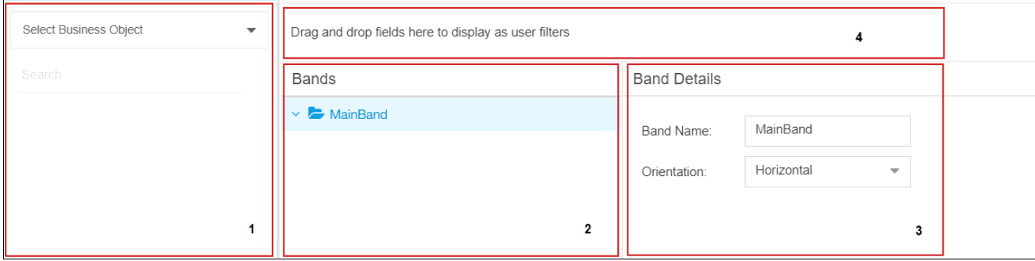

**Business Objects Area**

This section displays the available **Business Object**. When a business object is selected, available objects are displayed.

**Bands**

Bands section holds the Reports Structured template which we want to set them as default i.e. **Header,Footer.**

It comprises of

* Main Band (Root Band)
* New Band (Header)
  + Query(Where the Data values are set)

We can create any number of New Bands based on the requirement.

|  |
| --- |
| Note:   * When a Band is selected Band Details appear on the right. * When we click Query, Query Details are displayed on the right. * Band Name must be the same as we mention in  the Name field in the Excel/Word/HTML templates. |

**Band Details**

When a band is selected (here **Header**), its corresponding band details appear on the right under **Band Details** section.

Under **Band Details**, the following parameters appear:

* **Band Name**
* **Orientation: Horizontal or Vertical**

**Note: Horizontal Bands are copied downwards and Vertical to the right. Horizontal bands may contain sub-bands.**

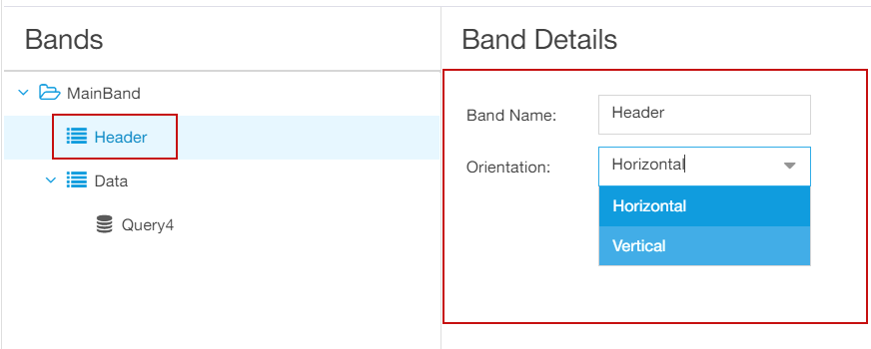

**User Filters**

User Filters are parameter-based filters that allow the user to input a value to filter the data in the report.

For a Publisher Report, the following components appear when a query is selected:

* Business Object Area (highlighted as “1”)
* Bands (highlighted as “2’)
* Query Details (highlighted as “3”) (This appears when a query is selected in **Bands** section.)
* Query (highlighted as “4”) (This appears when a query is selected in **Bands** section.)
* User Filter area (highlighted as “5”)

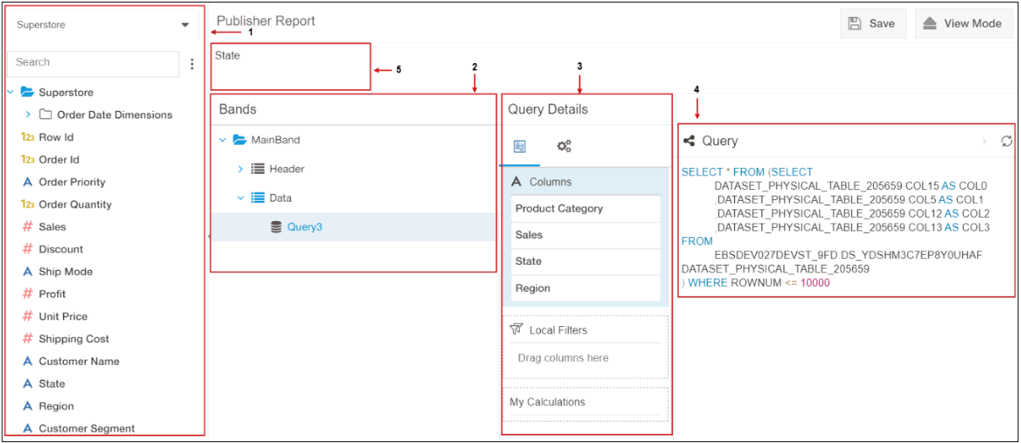

**Query Details**

**Query Details** section has the following:

* + **Configurator-** The objects dragged from BO area appear here. Based on the **Columns** in this section, query is built under **Query** section.
  + **Local Filters -** They are used to segregate huge data in the database while building reports.
  + **(Query Settings)** - This section provides the option to configure Row Limit, Query Timeout, and Select Distinct options.

**Query**

When the columns are dragged into the **Configurator** from BO area into **Query Details**, the query is automatically generated in **Query** section.

## Creating a Publisher Report

**Steps to Create a Publisher Report**

1. In the Orbit Application click  **Reports**, click  and then click **Publisher Report**.
2. A new window appears with **Select Business Object**, **Bands**, and **Band Details** sections (highlighted as “1”).
3. In the **Select Business Object** area, select the required Business object.
4. The columns under the selected business object (highlighted as “2”) appear.

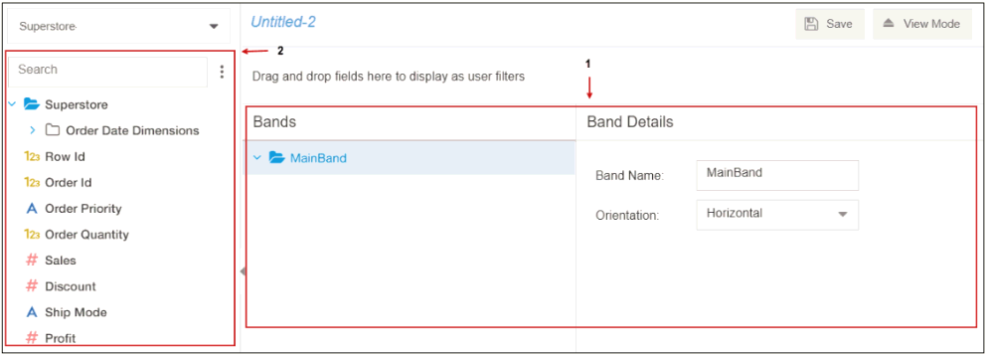

1. Under the **Bands** section, **MainBand** appears.

|  |
| --- |
| Note:   * One band can have multiple child bands under it and a band can also have multiple queries under it. * Bands in the Publisher Report maps to Names in Excel sheet. |

1. On the MainBand, right-click and then select **New Band** to create a new band (OR) Hover the cursor on the MainBand, click , and then click **New Band** (highlighted as “3”)..

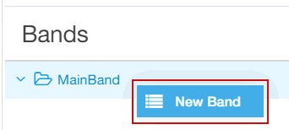        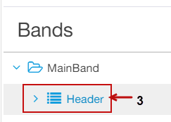

When a specific band is selected, the **Band Details** appear on the Right side.(highlighted as “4”).

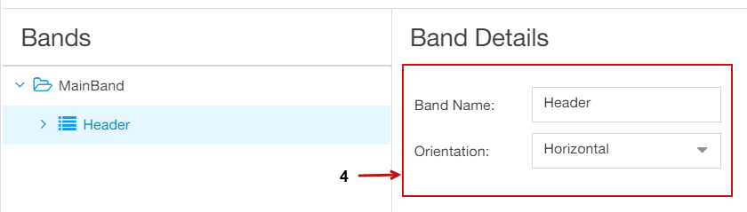

|  |
| --- |
| Note:   * You can change the Band name either by double-clicking it or you can change it under **Band Details.** * The default orientation is **Horizontal**. You can change the orientation to **Vertical** as well. The orientation describes direction of the data display. * Here, **Header** band is for the Header band that we created in the excel sheet. Now, we would be creating data band to extract the data under **Header.** |

     7. On the **MainBand**, right-click and then select **New Band** to create a new band (OR) Hover the cursor on the **MainBand**, click , and then click **New Band**.

1. On the **Data** band (highlighted as “5”), right-click, and then Select **New Query** (OR)Hover the cursor on the **Data** band, click , and then click **New Query**.
2. **Query Details** (highlighted as “7”) and **Query** (highlighted as “8”) sections appear.

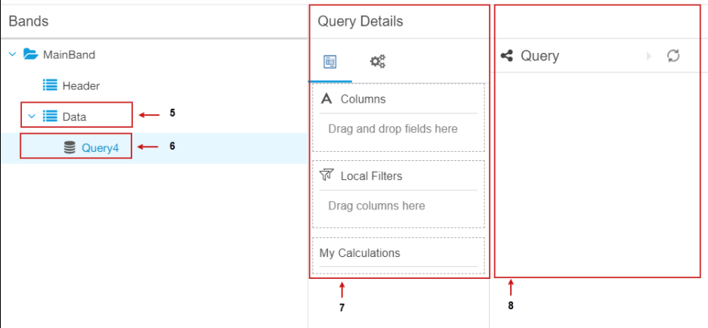

1. Drag and drop the objects into the Columns from Business Object area to the **Configurator** under **Query Details.**
2. To build your own Calculation , click ****next to **My calculations** and then click **New Calculation.**
3. Under the **Query** section, a query is built based on the dragged columns.For a quick check of the output click    and to refresh the query click as shown in the figure below.

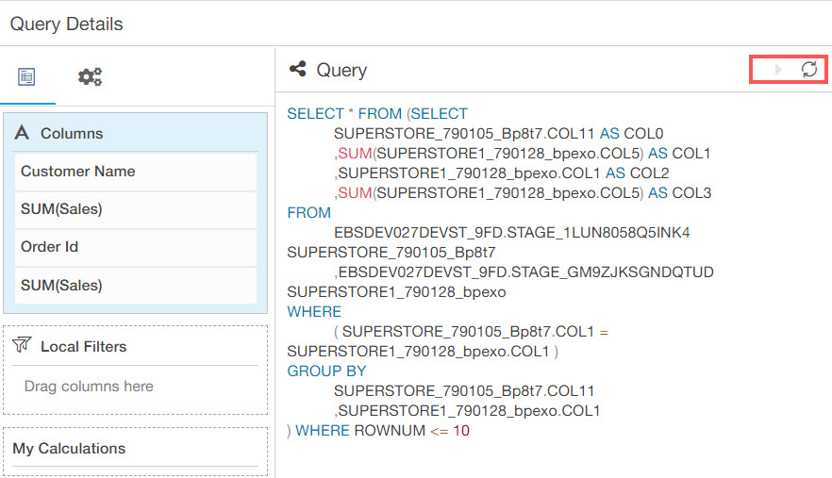

13 . Save the report under appropriate folder, by clicking **Save** a message of ****appears on the top.

## Creating Templates

### Creating Templates

This section deals with creating the following:

* Creating an Excel Template
* Creating a Word Template
* Creating a HTML Template
* Creating a FTL Template
* Creating an Excel Template for Grouping

### Output Compliance Matrix

The reports we generate can be viewed in the below mentioned Output formats.

|  |  |  |  |  |  |  |  |
| --- | --- | --- | --- | --- | --- | --- | --- |
| **Template / Output** | **XLSX** | **XLS** | **DOCX** | **DOC** | **PDF** | **HTML** | **TXT** |
| **XLSX** |  |  |  |  |  |  |  |
| **XLS** |  |  |  |  |  |  |  |
| **DOCX** |  |  |  |  |  |  |  |
| **DOC** |  |  |  |  |  |  |  |
| **HTML** |  |  |  |  |  |  |  |
| **FTL** |  |  |  |  |  |  |  |
|  | | | | | | | |

### Creating an Excel Template

**Steps to Create an Excel Template**

1. Open the **Excel Sheet**.
2. In the Excel sheet, enter the Header (E.g Company Name) in the column as shown in the below figure (highlighted as 1)

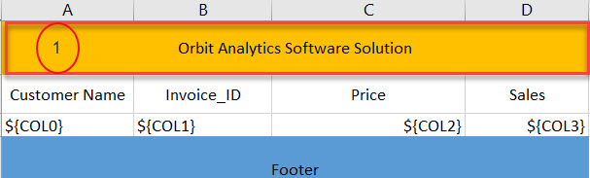

3. Enter the required field Names (E.g Customer Name, Invoice_ID) to extract the column values under it as shown in below figure (highlighted as 2)

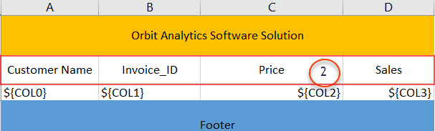

 4. Enter the column values **${COL0}**, **${COL1}** and so on, these should be the same as mentioned in the **Query** section in Publisher Report. As shown in the figure below,

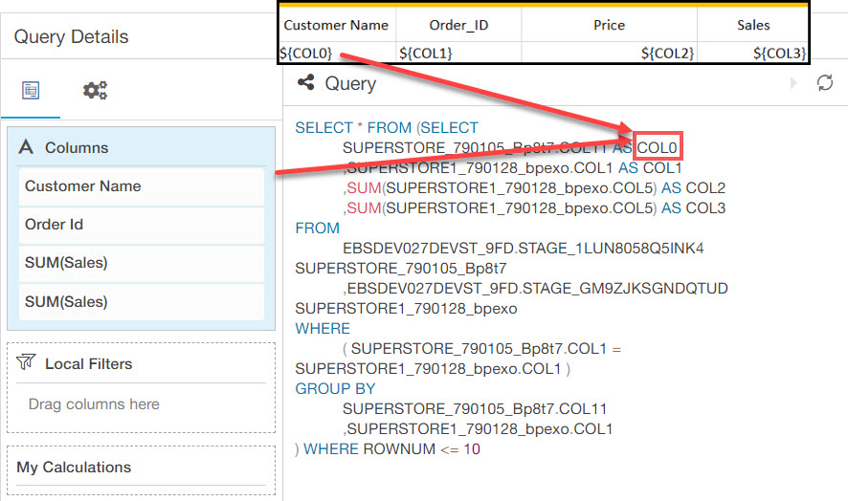

Now,create different **Names**( E.g Header, Footer etc.) in the Excel sheet similar to **Bands** name in **Orbit Publisher Report**.   
    
    
**Steps to Create a Name in Excel Sheet**

1. On the Ribbon click **Formulas**, in the **Defined Names** group, click **Name Manager.**

**2. Name Manager** dialog box appears.

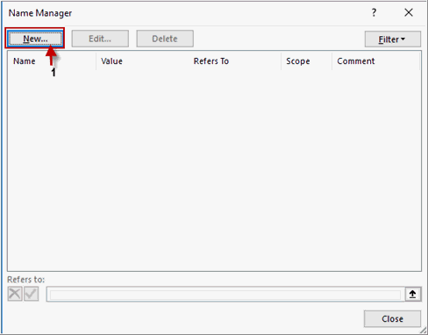

3. To create a new band, click **New** (highlighted as “1”).

**4. New Name** dialog box appears.

5. In the **New Name** dialog box, perform the following:

* In the **Name** box, type the name of the band.

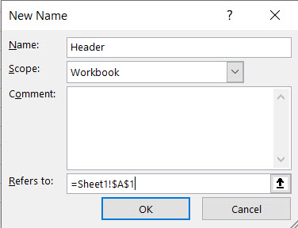

* To enter the values in the **Refers to** box, click  beside the **Refers to.**
* **New Name – Refers to** dialog box appears with the cursor inside the textbox, once the required cells are selected the formula appears, refer the below image.

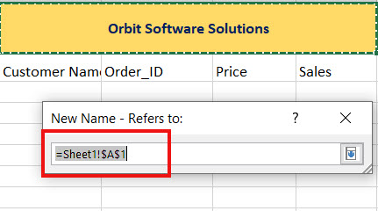

* Click to navigate to the **New Name dialogue box.**
* The selected cell values appear in the **Refers to** textbox as shown in the figure below.

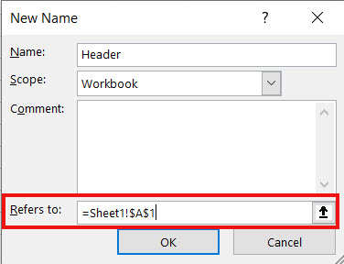

* To save the changes, click **OK**.
* The Band name appears in the **Name Manager** dialog box as shown in the figure below.

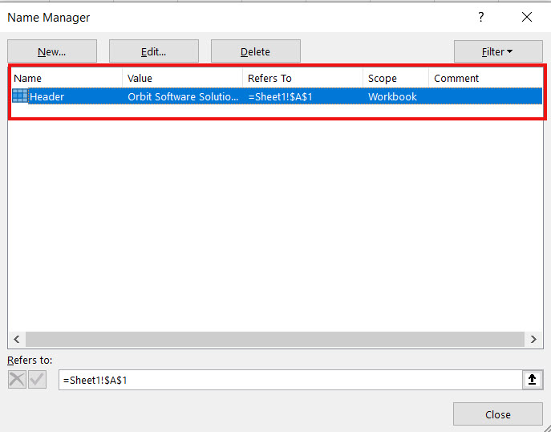

* To close the dialog box, click **Close**.
* Now create a **New Name band** “**Data**”, and place the column values **${COL0}, ${COL1}** and so on in the **Data** band using the above process.
* Save the Workbook with an appropriate name and click Close.

|  |
| --- |
| Note:   * If a **New Band**  is created in the Publisher Report and if we don't create a Name Manager in the template then the contents wont be displayed in the Output file. * Table and Pivot cannot be used for creating templates in Excel. |

### Creating a Word Template

**Steps to Create a Word Template:**

1. Open the **Word document.**

2. Type in the Content area as “${Reportdata.COL0}"refer the below figure i.e. The same **Band name** mentioned in the Publisher Report under **MainBand.**

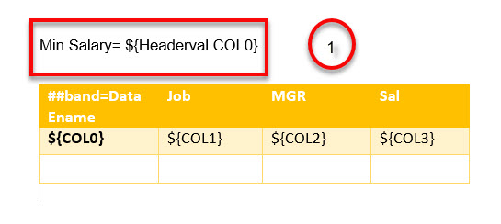

E.g. Here, Minium Salary is the filter..

3. As shown in the figure below to extract the column values mention in it as “**##band=Data**” (highlighted as “2”). Type the required **Column Names.** E.g. Ename, Job etc.

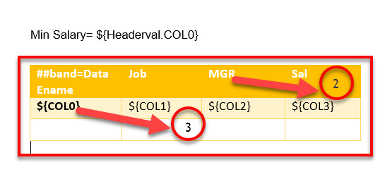

4. To extract the column values under the required columns, enter the column numbers as **${COL0}, ${COL1},** and so on as shown in the above figure.(Highlighted as "3")

5. Save the **Word document** with an appropriate name.

|  |
| --- |
| Note:   * To retrieve the vales in multiple fields we need to insert a table in the Word Template file |

### Creating an HTML Template

To create the Template in HTML the below mentioned code need to be provided for the **Style elements**.

The **Style elements** must be placed between <head> and </head> tags.

|  |
| --- |
| <head> <meta charset="UTF-8"> <title>Untitled Document</title> <style type="text/css"> .report-table-details {   margin-bottom: 0px;   border: solid #dfdcdc 1px;   min-width: 550px;  }  .report-table-details th {   background: #1777cb;   padding-top: 8px;   padding-bottom: 8px;   color: #fff;   text-align: left;   padding-left: 20px;   font-size: 14px;   font-family: lato;  }  .report-table-details td {   padding-top: 10px;   padding-bottom: 10px;   padding-left: 20px;   padding-right: 20px;   color: #fff;   font-family: lato;   font-size: 14px;   border-right: 1px solid #dfdcdc;   border-bottom: 1px solid #dfdcdc;  }  .report-table-details td:first-child {   font-weight: bold;   color: #5a5a5a  }  .report-table-details td:last-child {   padding-left: 20px;   color: #1777cb;   border-right: none  }  .report-table-details tr:last-child td {   border-bottom: none  }  .report-table {   border: solid #dfdcdc 1px;   font-family: lato;  }  .report-table th {   background-color: #1777cb;   color: #fff;   font-size: 14px;   padding-top: 10px;   padding-bottom: 10px;   border-right: 1px solid #dfdcdc;   text-align: left;   padding-left: 30px;  }  .report-table th:last-child {   border-right: none;  }  .report-table td {   color: #5a5a5a;   font-size: 13px;   padding-left: 30px;   border-right: 1px solid #dfdcdc;   border-bottom: 1px solid #dfdcdc;   padding-top: 8px;   padding-bottom: 8px;  }  .report-table td:last-child {   border-right: none;  }  .report-table tr:nth-child(even) {   background: #fff  }  .report-table tr:nth-child(odd) {   background: #f8f8f8  }  .reportgrid-title {   font-size: 40px;   color: #5a5a5a;   font-family: lato;   float: left;   font-weight: bold;   margin-bottom: 20px;   margin-top: 20px;  }  .report-table tr:last-child td {    border-bottom: none  }  .details-div {   clear: left;  }  .cust-logo {   float: right;   margin-top: 30px;   margin-right: 30px;  }  .cust-logo img {   width: 130px;  }  </style> </head> |

The following code provides the **Data** for the required columns. Place the following code in between the tags <body> </body>.

**Band is assigned in the following code as <#assign groups = Root.bands.Header>.**

|  |
| --- |
| <body>   <div style="margin: 0px auto;">   <div class="details-div">   <#assign groups=Root.bands.Header>   <br>   <#list groups as Hname>   <table width="100%" class="report-table" border="0" cellpadding="0" cellspacing="0">    <tbody>     <tr>   <th scope="col">Name</th>   <th scope="col">${Hname.fields.COL0}</th>   </tr>   <tr>   <th> CUTOMER NAME</th>   <th> PRIORITY</th>   <th> ORDER DATE</th>   <th> QUANTITY </th>   <th> UNIT PRICE</th>   <th> TOTAL</th>   </tr>     <#list Hname.bands.Data as data>   <tr>   <td nowrap=true> ${data.fields.COL0} </td>   <td nowrap=true> ${data.fields.COL1} </td>   <td nowrap=true> ${data.fields.COL2} </td>   <td nowrap=true> ${data.fields.COL3} </td>    <td nowrap=true> ${data.fields.COL4} </td>   <td nowrap=true> ${data.fields.COL5} </td>   </tr>   </#list>   </tbody>   </table>   </#list>   </div>     </div>  </body> |

### Creating a FTL Template

The output for FTL Templates is available in **HTML and TXT**.

* The following code provides the required style elements for the FTL Template .
* The style elements must be placed between <head> and </head> tags.
* The below mentioned code must be placed in between <html> and </html> tags.

|  |
| --- |
| <head>  <meta charset="UTF-8">  <title>Untitled Document</title>  <style type="text/css">    .report-table-details{ margin-bottom: 0px; border: solid #dfdcdc 1px; min-width: 550px; }  .report-table-details th{background: #1777cb; padding-top: 8px; padding-bottom: 8px;   color: #fff; text-align:left; padding-left: 20px; font-size: 14px;font-family: lato;}  .report-table-details td{ padding-top:10px; padding-bottom: 10px; padding-left: 20px; padding-right: 20px;color: #fff; font-family: lato;  font-size: 14px;border-right: 1px solid #dfdcdc; border-bottom: 1px solid #dfdcdc; }  .report-table-details td:first-child{font-weight: bold; color:#5a5a5a}  .report-table-details td:last-child{ padding-left:20px; color: #1777cb; border-right: none}  .report-table-details tr:last-child td{border-bottom: none}    .report-table{border: solid #dfdcdc 1px; font-family: lato; }  .report-table th{ background-color: #1777cb; color: #fff; font-size:14px; padding-top: 10px; padding-bottom: 10px;  border-right: 1px solid #dfdcdc; text-align: left; padding-left: 30px;}  .report-table th:last-child{border-right: none;}  .report-table td{  color: #5a5a5a;font-size: 13px; padding-left: 30px;border-right: 1px solid #dfdcdc; border-bottom: 1px solid #dfdcdc; padding-top: 8px; padding-bottom: 8px; }  .report-table td:last-child{border-right: none;}  .report-table tr:nth-child(even) {background: #fff}  .report-table tr:nth-child(odd) {background: #f8f8f8}  .reportgrid-title{ font-size: 40px; color:#5a5a5a; font-family: lato; float: left;font-weight: bold; margin-bottom: 20px; margin-top: 20px;}  .report-table tr:last-child td{border-bottom: none}  .details-div{clear: left;}  .cust-logo{ float: right; margin-top: 30px;margin-right:30px; }  .cust-logo img {width: 130px;}  </style>  </head>  <body>  <div style="margin: 0px auto;">  <div class="details-div">  <#assign tabledata = Root.bands.Data>    <table width="100%" class="report-table" border="0" cellpadding="0" cellspacing="0" >  <tbody>    <tr>              <th> EMPNO</th>              <th> EName</th>              <th> SAL</th>              <th> MGR</th>    </tr>      <#list tabledata as data>  <tr>              <td nowrap=true> ${data.fields.COL0} </td>  <td nowrap=true> ${data.fields.COL1} </td>  <td nowrap=true> ${data.fields.COL2} </td>                          <td nowrap-true> ${data.fields.COL3} </td>    </tr>      </#list>    </tbody>  </table>  </div>    </div>  </body> |

Save the file with **.ftl** as an extension and click **Save.**

**HTML Output**

The HTML Output for the above-mentioned code appears as follows:

**TXT Output:**

TXT Output for the above-mentioned code is as follows:

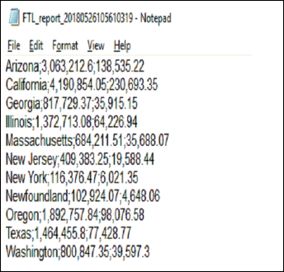

**Excel Output:**

To view the TXT File data in Excel, import the data into excel from “. TXT” file, and then view the output in excel. The output appears as follows:

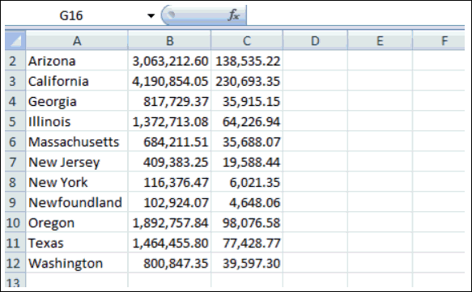

## Applying Various Templates to Publisher Report

### Applying Templates to Publisher Report

To view a Publisher Report in Excel, perform the following:

* Creating a Publisher Report
* Applying Excel Template to Publisher Report

### Applying Excel Template to Publisher Report

|  |
| --- |
| Note:   * Prior applying an **Excel Template** to a Publisher Report, the user must have an existing Template available in Microsoft Excel.  See Creating an Excel Template for more information. |

**Steps to Apply Excel Template to Publisher Report**

1. On the extreme right-hand side, click **Options**, and then click **Templates** (highlighted as “1”).

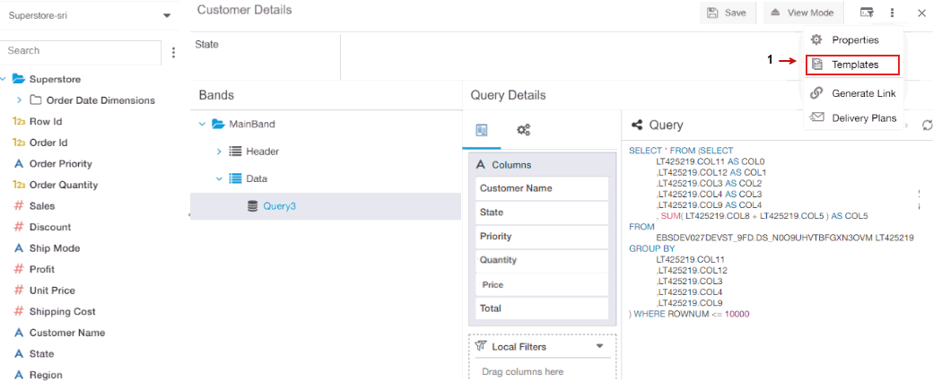

1. **Templates** dialog appears,to create a new template, click **New Template**.

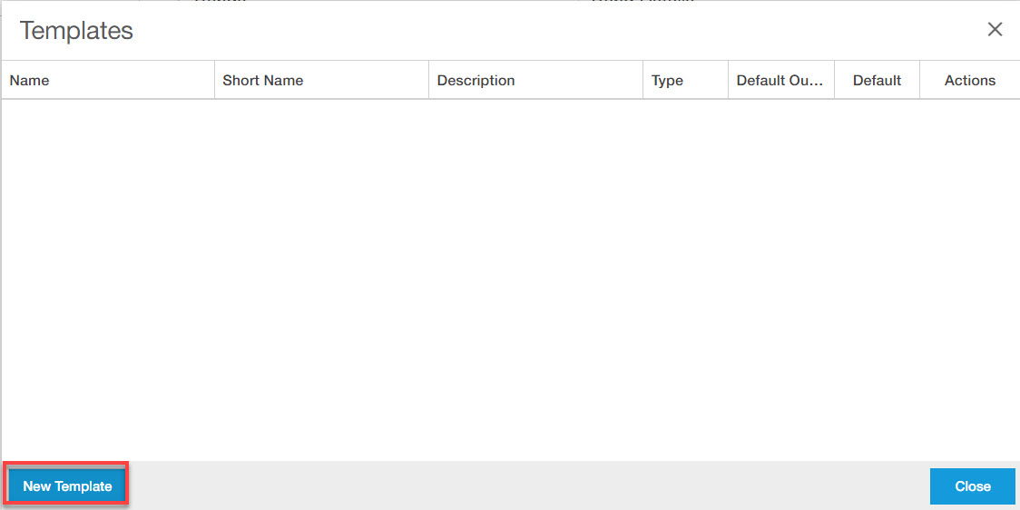

3. Enter the required details in the **Templates** dialogue box.

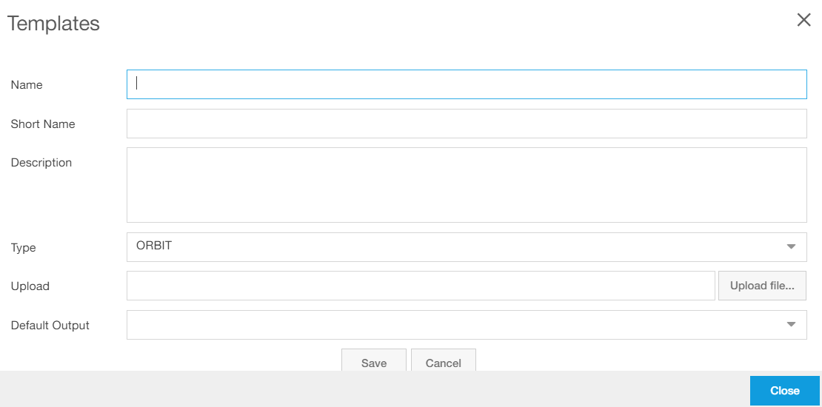

4.  In the **Name** box, type the name of the template.

5.  In the **Short Name** box, type the short name for the template.

|  |
| --- |
| Note:   * This field accepts only Aplha-Numeric without space |

6.  In the **Description** box, type the description.

7.  In the **Type** box, “**ORBIT**” is selected by default.

8.  To upload the required template, click **Upload file** that appears next to the **Upload** textbox.

9.  In the **Default Output** box, type/select the required default output option depending upon the template.

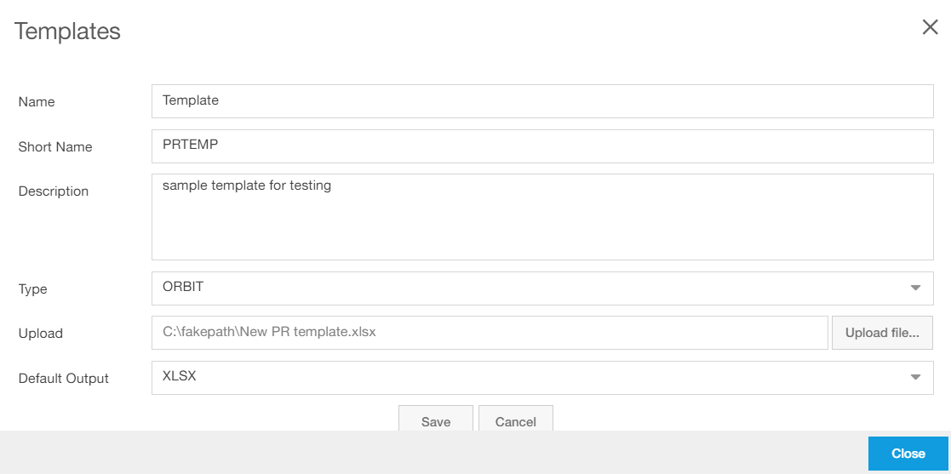

10. To upload the template, click **Save.**

11. The uploaded template appears under **Templates.**

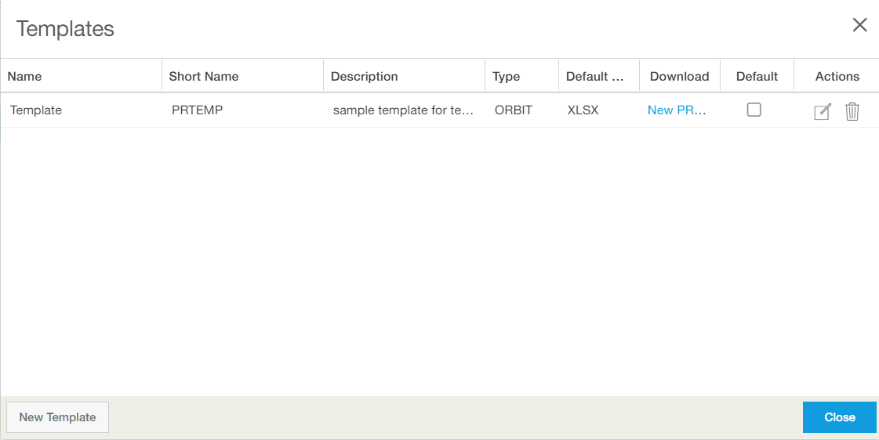

12. To make the template as a default template, select the required template, and then click **Make** **Default** (highlighted as “2”).

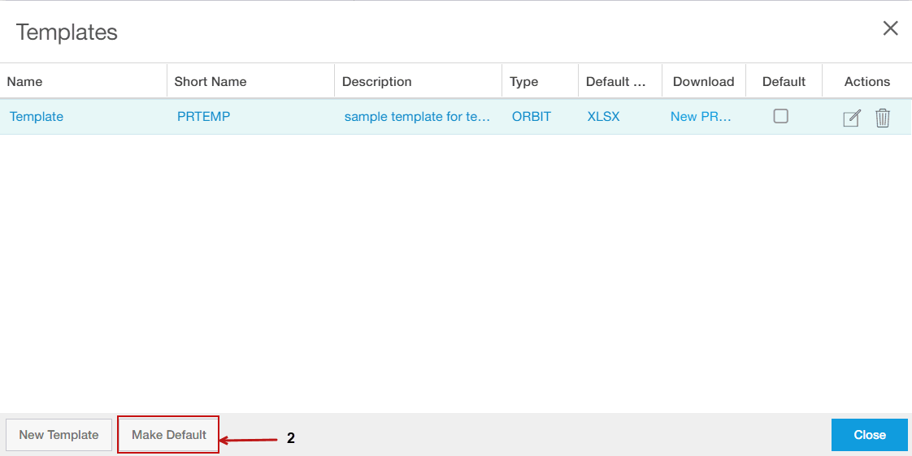

13. A checkmark (highlighted as “3”) appears in the **Default** checkbox for the selected template.

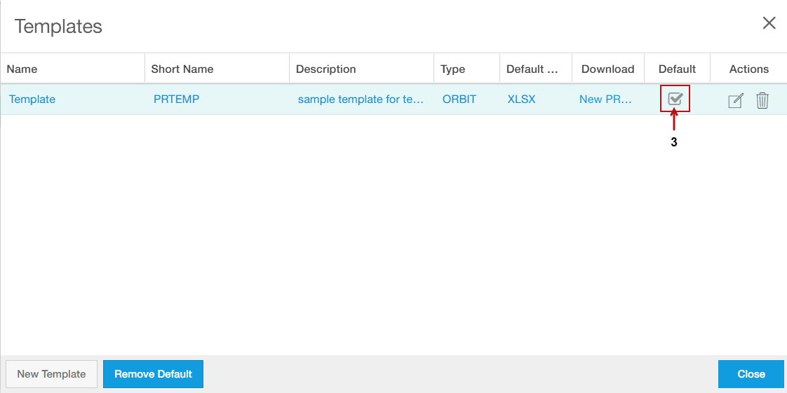

14. To remove the selected template from being a default template, click **Remove Default**.

15. To close Templates box, click **Close.**

### Applying Word Template to Publisher Report

|  |
| --- |
| Note:   * Prior applying the Word Template, User need to have an existing **Word Template.** See Creating a Word Template for more information. |

1. For the Minimum Salary as a parameter, provide the required filter in the **Query Details** of **Publisher Report.**

* Define the **New Band(**Highlighted as 1**)** and add a New Query drag the **SAL object** into the column and mention **Aggregation** as **Min** (Highlighted as 2) automatically the **Query** is built( Highlighted as 3)as shown in the figure below.

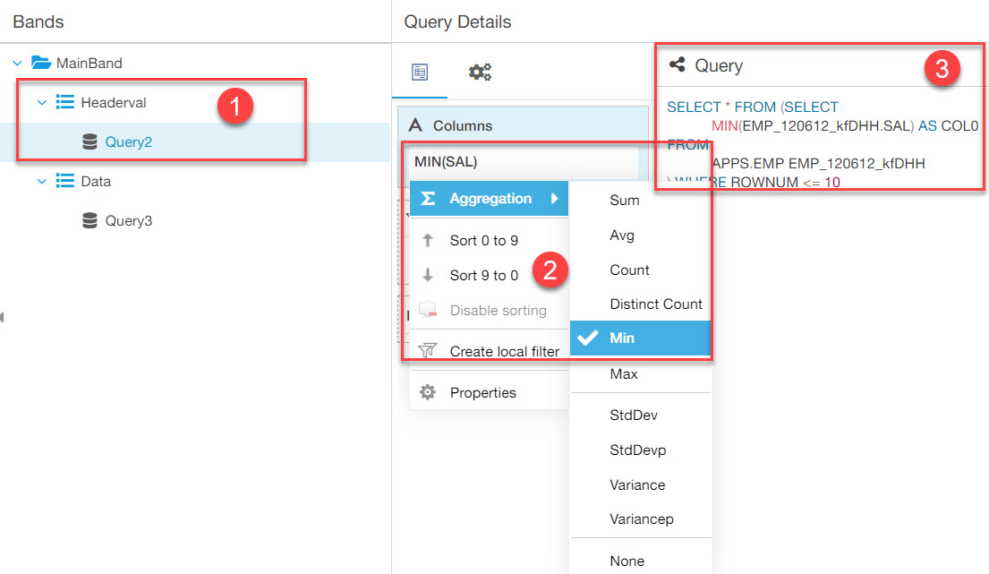

**Word Template** need to be uploaded in a similar way as Excel Template in the Publisher report. For more details see *Applying Excel Template to Publisher Report*

2. Click **Save**, *Report saved Successfully* message appears 

### Applying HTML Template to Publisher Report

|  |
| --- |
| Note:   * User need to have an existing HTML Template to be applied. See Creating a HTML Template for more details |

1. Perform the process of Applying grouping in the Publisher Report.

2. Upload the Template file in a similar way as Applying Excel Template to Publisher Report

3. Click **Save** message appears on the top.

### Applying FTL Template to Publisher Report

|  |
| --- |
| Note:   * Prior applying the FTL Template user need to have an existing once. See How to Create an FTL Template for more information. |

1. Upload the FTL Template, as in Applying Excel Template to Publisher Report
2. Save the **Report.**

## Viewing Publisher Reports in Various Output Types

### Viewing the Excel Template Output

1. Once the **Excel Template is applied and the report is saved.** then click **View Mode.**
2. **View Mode** appears, In the **Select template** box, the default Excel template appears.
3. In the **Select Output** box, the default output appears.
4. To Run the report, click **Run**.
5. The report appears in the excel sheet as follows:

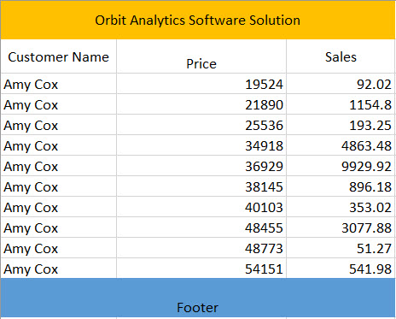

Procedure for changing the Order of the Columns

|  |
| --- |
| * If you need to change the order of the columns in the ORBIT Publisher, you must change the template accordingly. * For Example, in the excel template “**Customer Name**” is the first column($COL0) and “**State**” is the second column ($COL1). * If you want to display the “**State”** as the first column and “**Customer Name**” as the second column (as displayed in the figure below), then you must change it in the EXCEL Template as shown in the figure above and repeat the above procedure to Add the template once again and run the report. * If the user tries to export the Excel Template as HTML output, the output file generates only first sheet of the excel. |

To view the report in PDF format, select the required Template, select the Output Type as PDF, and then click **Run**.

### Viewing Publisher Report in Word

1. Click **View mode,** select the required **Template** (Highlighted as 1) from the drop down and the **Output Type** (Highlighted as 2) as shown in below figure and click **Run.**(Highlighted as 3)

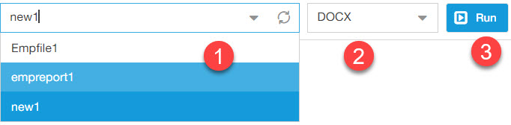

2.  The report opens in a word document as shown in the below figure.

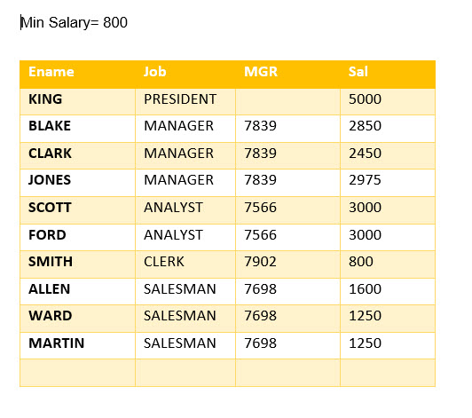

### Viewing Publisher Report in HTML

1. Click **View Mode.**
2. In the **Select template** box, select the required template.
3. In the **Select Output** box, select the required output( E.g. HTML) from the available outputs.
4. To run the report, click **Run**. The Output is displayed as mentioned below.

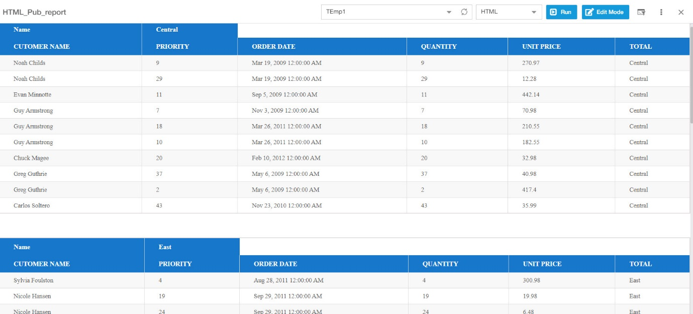

Note:

As the grouping is done we can view the output accordingly.

### Viewing Output in Required Format

1. Switch to **View Mode.**
2. In the **Select template** box, select the required template.(Highlighted as 1)
3. In the **Select Output** box, select the required output from the available outputs.(Highlighted as 2)
4. To run the report, click **Run.**(Highlighted as 3)

#### HTML Output:

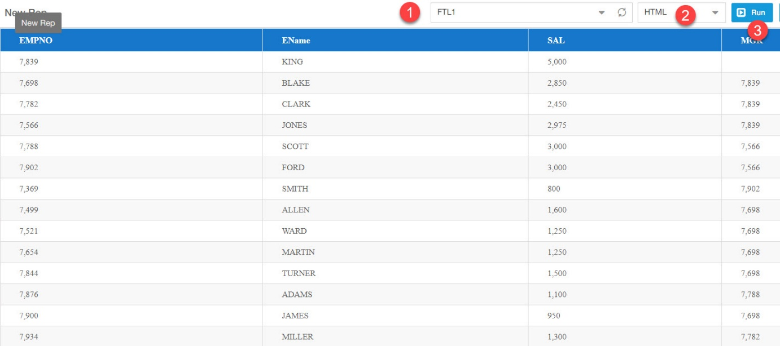

#### TXT Output.

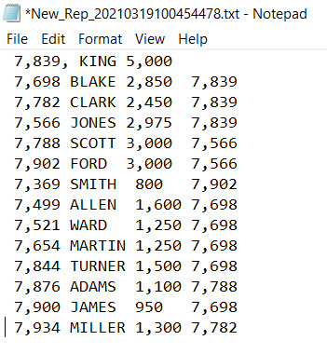

## Grouping in Publisher Report

### Creating an Excel Template for Grouping

**Steps to Create an Excel Template for Grouping**

1. Open the **Excel Sheet.**

2. In the Excel sheet, enter the required **Columns** in the Header section as shown in the below figure.

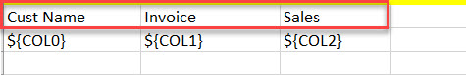

.3. To extract the column values under the required columns, enter the column numbers as ${COL0}, ${COL1}, and so on (highlighted as “2”).

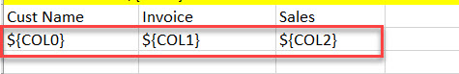

4. Now select the first two rows and group them under one band as “**Header**” in the **Name Manager** as shown in the figure below.

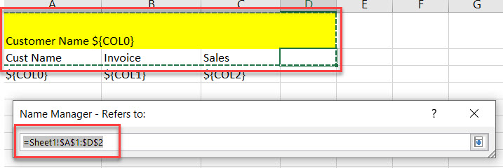

|  |
| --- |
| **Note**:   * Band Name in the ORBIT Publisher Report must be the same as the band name mentioned in the template. |

### Performing Grouping on Publisher Report

Prior performing grouping in the Publisher Report in ORBIT and view the output in Excel, you must have the template ready with required filter.

For more information, see Creating an Excel Template for Grouping

1. Open a New report under the **Bands**section, **MainBand** appears.In the **MainBand**, right-click and then select **New Band** to create a new band.

**E.g:** New Band: **Header** its the same Name created in Excel Template.

2. On the **Header** band, click the drop down and select **New Query. Drag and drop the required Business Objects in the columns in the Configurator area.**

3. Create a **Data** Band to extract the data under **Header**. Since **Data** Band is needed for every group, place the **Data** band under **Header**

**4. I**n the **Data** Band ,click the drop down and select **New Query**. A new query appears refer below figure.

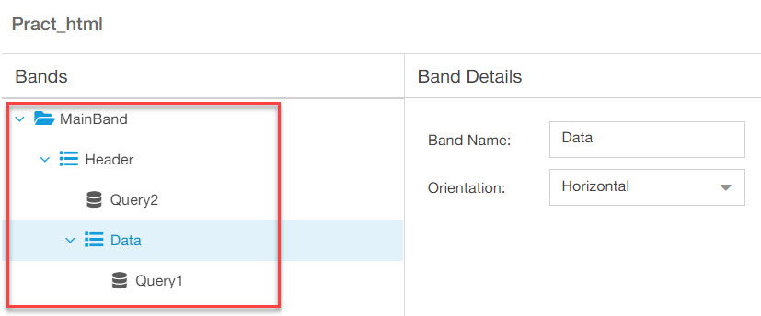

5. Select the Query **Query Details**  and **Query** sections appear drag and drop the required Business Objects under columns automatically the Query is generated.

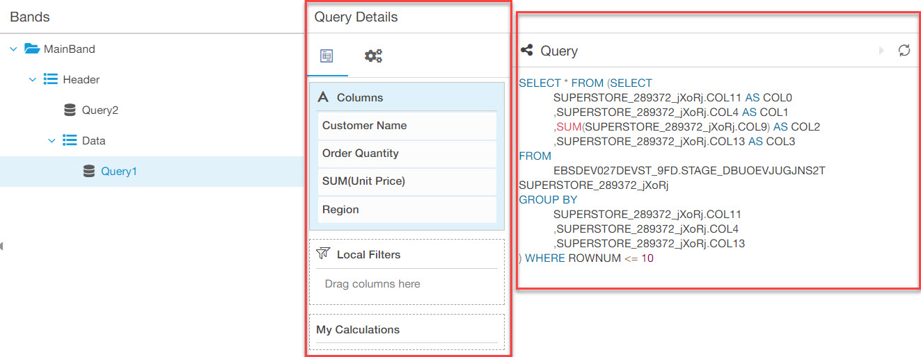

6. Drag the required Business Object in the Column (E.g: Region) in the **Local Filters** and to build your own calculations click click **New Calculation**

7. **Calculation Formula** dialogue box appears, mention the **Name** and build a formula as shown in the figure below. Click **OK**

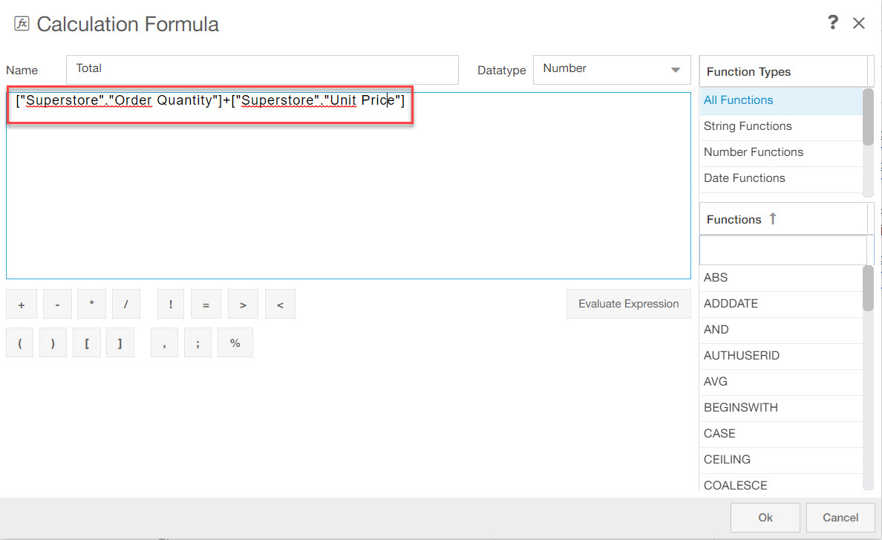

8. Under the **Query Details the Calculation built is dragged as shown in the figure below.**

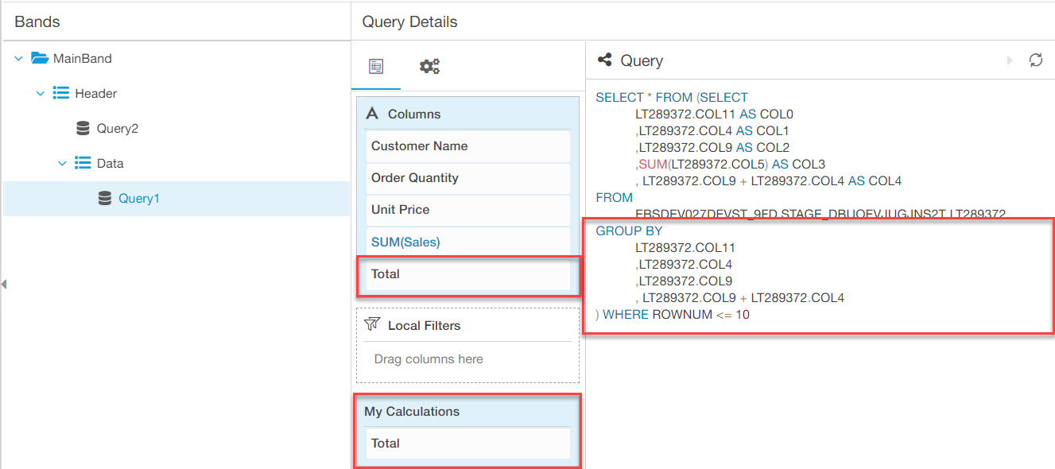

Note: Since the grouping is done, add the **Local Filters** for the Query under **Header as shown in the figure below.**

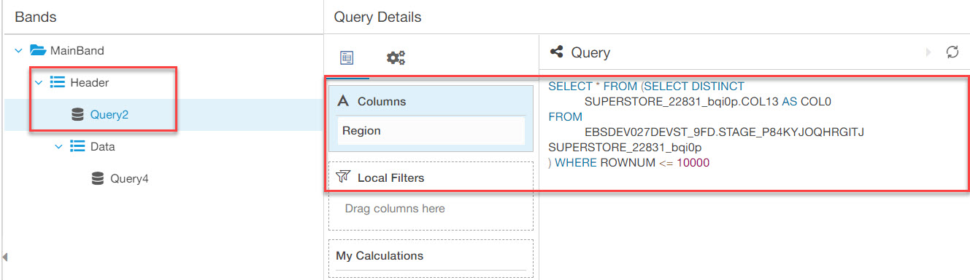

**9.** Select the Query under **Data**band, and then select the **Local** **Filters** section under **Query Details**.

10. Drag and drop the required Business Object in the column of the Local Filters click Edit. 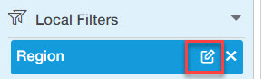**E.g:** Region

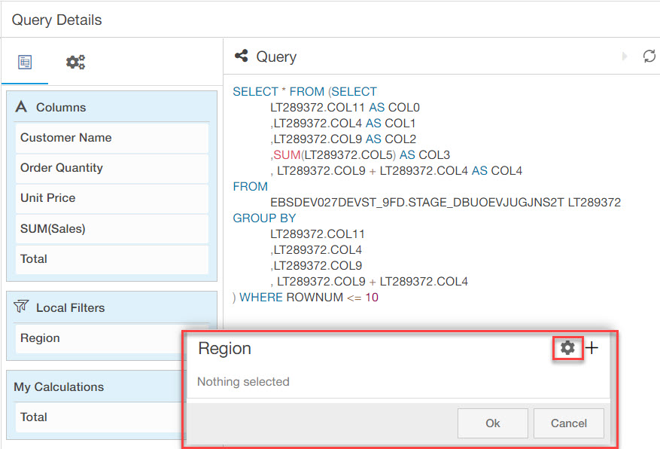

For the required filter, click as shown in the above figure

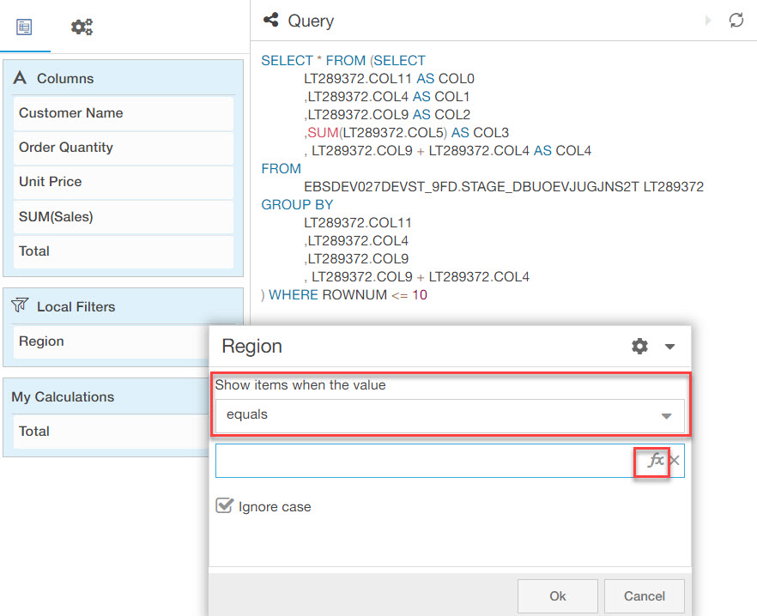

From the “**Show items when the value**” list, select the required option from the drop down. **E.g:** Equals

Under the list, in the textbox, enter the **Value** for the filter or **Choose Valve,** click  as shown in the figure below and click **OK**

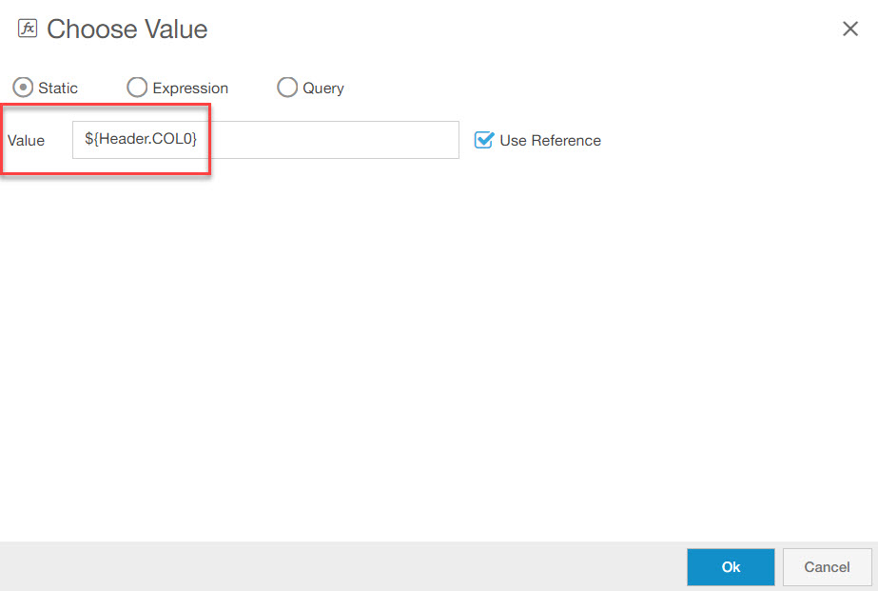

Note: Valve: ${Header.COL0} Region column in the configurator area is at **COL0**

**11.** Save the report under appropriate folder, click **Save.**

12. Apply the Excel Template to the report See *Applying Excel Template for Publisher Report* for more details.

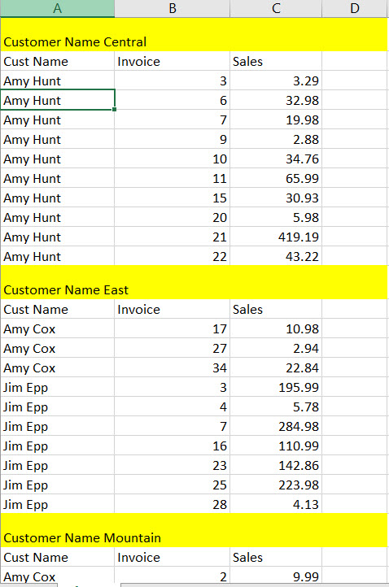

|  |
| --- |
| Note:  Grouping is possible only in Excel and HTML; grouping cannot be done in Word templates. |

## Template with Bind Variables

### Template with Bind Variables

**Bind Variables**

Bind Variables are the dynamic variables that accept the inputs or the parameters at run time.

This section explains two types of templates with Bind Variables:

* Excel Template with Bind Variables
* Word Template with Bind Variables

### Excel Template with Bind Variables

This section, explains about the Template with Bind  Variables and  how they are created.

The figure below displays various Bind variable with its Name and its associated Key values.

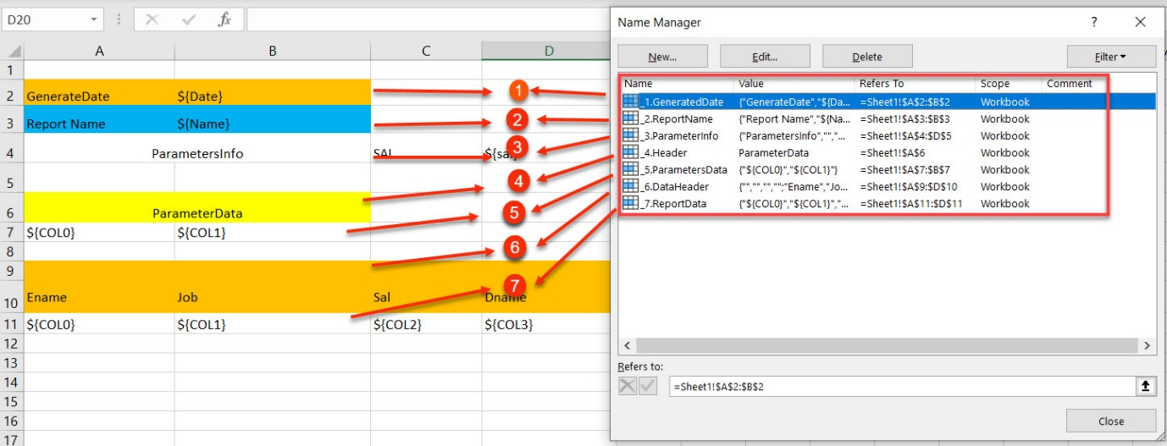

_1.GeneratedDate: Its associated key ${Date} displays information about the **Date and Time** the report had Run.

_2.ReportName: Its associated key ${Name} displays the Name of the report.

_3.ParametersInfo: Its associated key E.g. ${sal} is set as a User Filter here.

_4.Header: The header for the ParametersData

_5.ParametersData: The User Filter data is displayed here column wise in ${COL0}, ${COL1}

_6.DataHeader: The field names for the contents in  the reports (E.g. Ename,Job,Sal,Dname)

_7.ReportData: The Report data which is extracted gets displayed here.

The **Names** mentioned in **Name Manager** field of Excel are the **Standard Notations** which the User cant change. Below is the List of **Standard Notations**

* GeneratedDate,
* ReportName,
* ParametersInfo,
* ParametersData,
* ReportData

If the user tries to change the Notations then the data wont be extracted from the reports

Note:

* We need to mention the Names as _1 or _2 so on to define the placing. Follow the rules mentioned below in the figure while defining a Name.
* Based on the notations given the data is extracted, the user has an option to customise the Template based on the Styles and while sequencing.

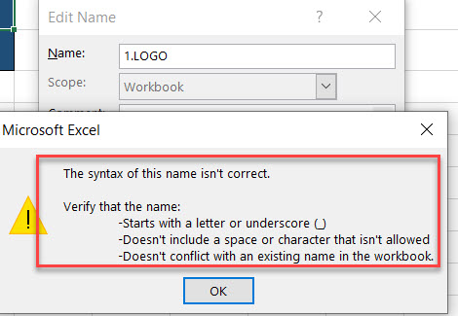

If the Notation **(E.g. ${Date} is changed to ${Dates}** then the data cannot be extracted as shown in the figure below.

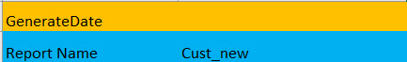

If we mention the notations properly it provides the actual information as mentioned below.

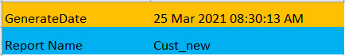

The ParametersInfo Name is picked from the User Filter set in Publisher Report as **sal** as mentioned in below figure.

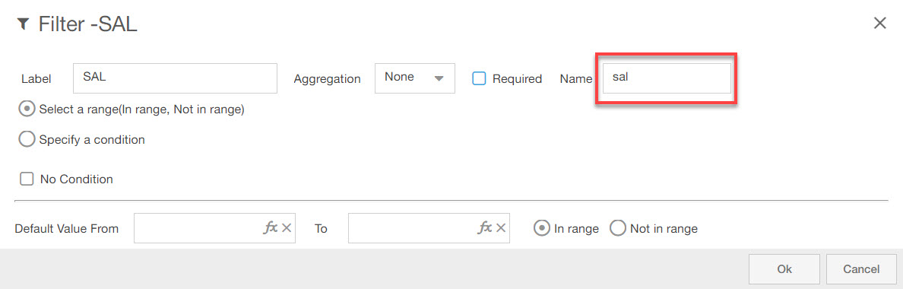

For the ParameterData, the keys ${COL0} and ${COL1} are picked from column names under the Query as shown below:

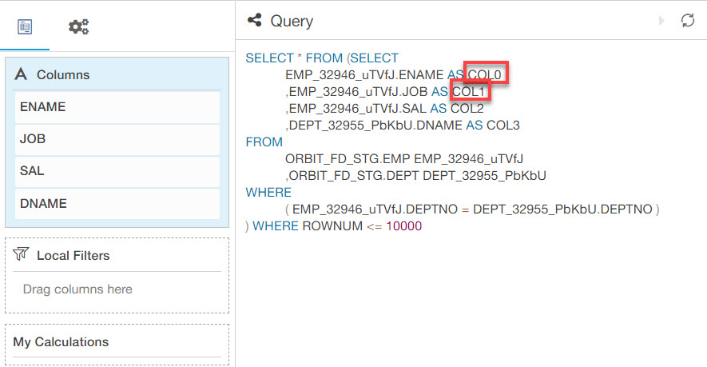

The Excel Output is displayed as below.

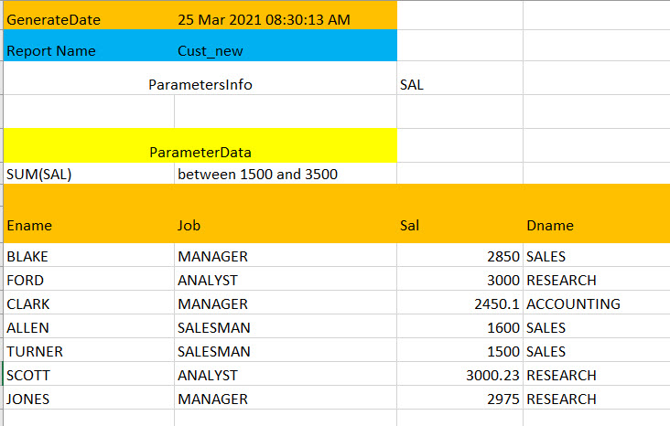

### Word Template with Bind Variables

This page discusses about creating a Word Template with Bind variables. The figure below displays various bind variable with its **Band Name** and its associated **Key values**.

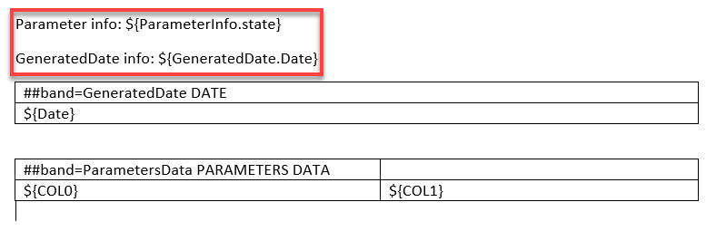

In the Word Template, the **Parameter information: ${Parameterinfo.state}** is defined using **${BandName.Key}** notation.

**ParameterInfo** is the Band name and **state** is the Key. Also, the **GeneratedDate** is the Band name and **Date** is the Key

The key in the **Parameterinfo** is picked from the **Name** of the selected User Filter. Here, the User Filter in the Publisher Report is State, and its **Name** is state as shown in the figure below.

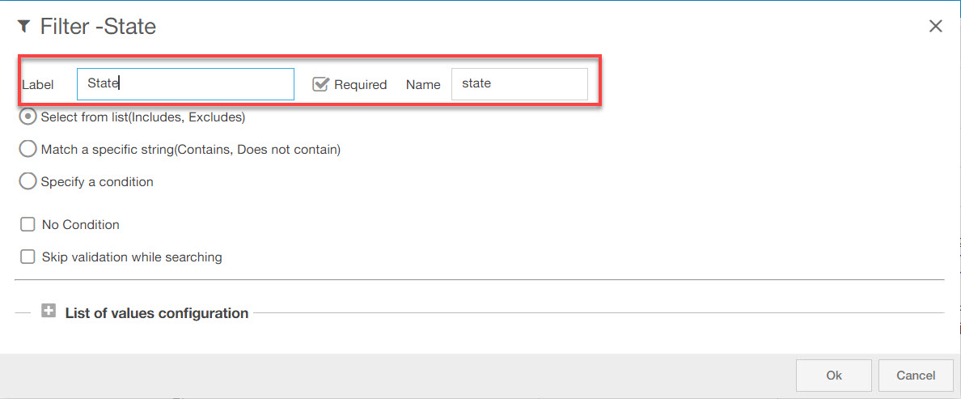

For the **ParameterData,** the keys ${COL0} and ${COL1} are picked from column names under the Query as shown below:



The output for the above Word Template is displayed below:

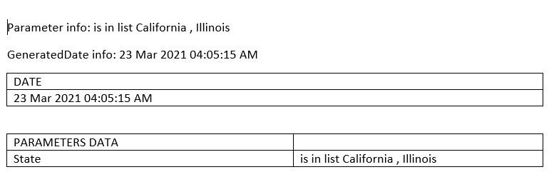

**Best Practice**

* It is recommended to create a publish report with the required columns prior to uploading the excel/word template using **Templates** option.

* Once the template is uploaded, switch to **View Mode** and then view the output.  See *Viewing the Output* for more information.

## Creating a Word Template with Grouping and Page Break

### Creating a Word Template with Grouping and Page Break

Create a Word template in the following format:

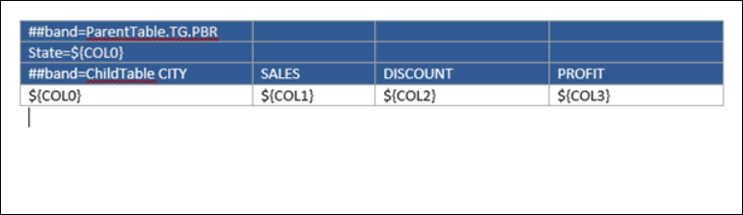

The above template illustrates that the ParentTable consisting of four rows.

The first three rows form the Heading and the fourth row forms the Data row.

* First Row: **##band=<BandName><dot><TG><dot><PBR>**

o   Where band_name = ParentTable

o   TG = Table Grouping (this implies that the table has a child table)

o   PBR= This implies that there should be a page break between the tables

* Second Row: ${COL0}
* Third Row: ##band=ChildTable
* Fourth Row (the data row}: ${COL0}, ${COL1}, ${COL2}, and ${COL3}

Once the table is created, apply **Repeat Header Rows** option to display header in every page.

To view the outputs and scenarios without Repeat Header Rows.

* Applying Repeat Header Rows Option
* Without Repeat Header Rows Option

### Applying Repeat Header Rows Option

**To apply the Repeat Header Rows in the Word template, perform the following:**

.1. Select the table and on the **Layout** menu, in the **Data** group, click **Repeat Header Rows**

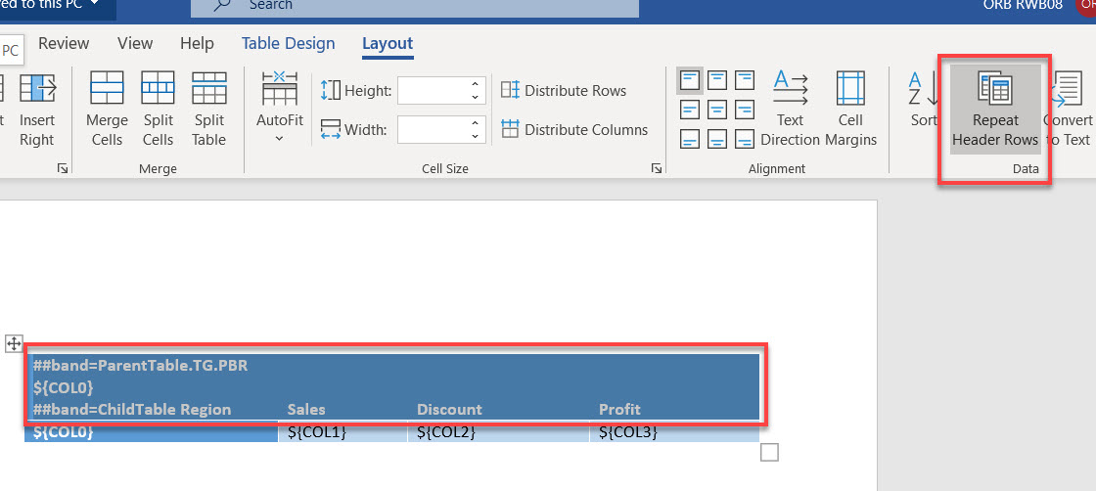

 When **Repeat Header Rows** is selected, it appears grayed as in the above figure and **Header** (the first three rows of the table) gets repeated for every page.

The output appears as displayed below:

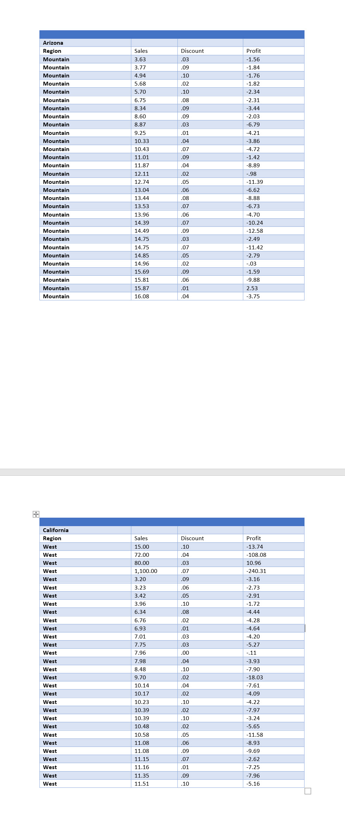

In the above figure, applying Table Grouping retrieves the data state-wise. Also, since the page break is applied in the word template, the data of Arizona state appears in a new page instead of tailing the data of California  state.

And, as the Repeat Header Rows option is selected, the Header appears in every page when the data continues to next page.

The following are the other different scenarios which have **Repeat Header Rows** option selected in the templates.

**Scenario 1: When Table Grouping is applied but there is no Page break**

In this scenario, there is no Page break applied; however, Table Grouping is applied.

The output for the above scenario is displayed below:

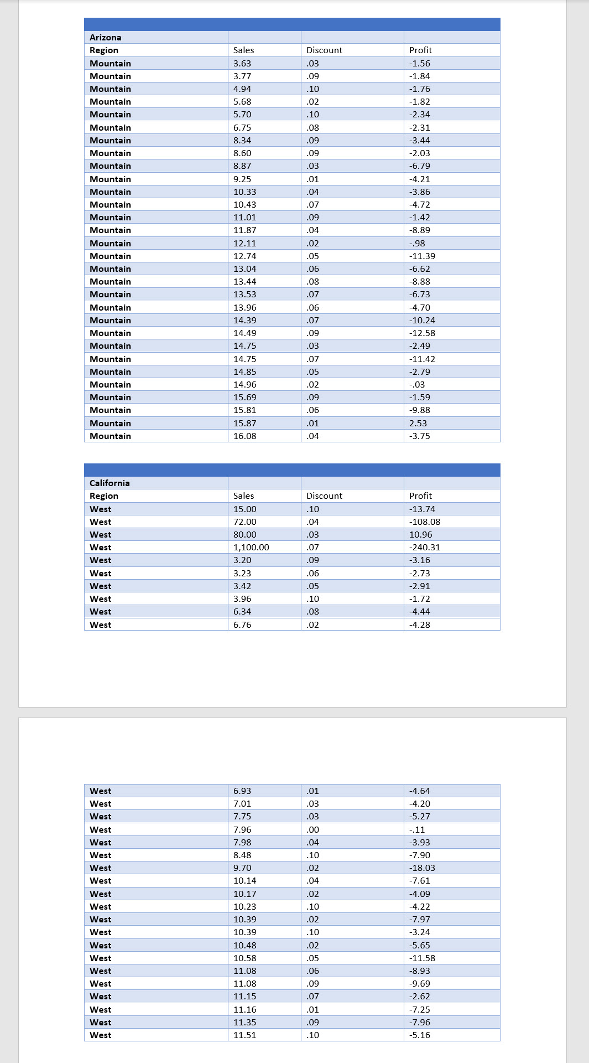

In the above figure, since no page break is applied in the word template, the data of Arizona state is followed by the data of California state in the same page. Also, as the Repeat Header Rows option is selected, the Header appears in every page when the data continues to next page.

**Scenario 2: No Table Grouping and No Page Break**

**I**n this scenario, no Table Grouping and no Page Break are applied.

The output for the above scenario is displayed below:

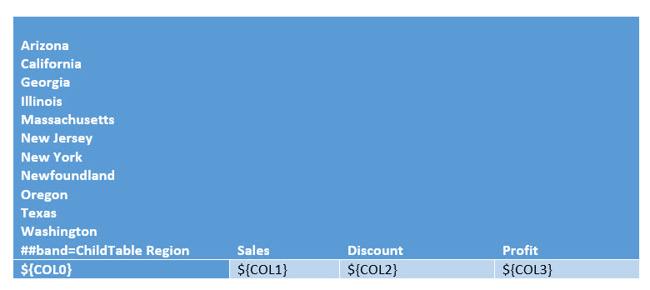

When no Table Grouping or no Page Break is applied, then it’s a normal table.

### Without Repeat Header Rows Option

The below scenario displays the output where “Repeat Header Rows” option is not applied.

**Scenario1:**

When **Repeat Header Rows** option is not selected in Microsoft Word; however, Table Grouping and Page break is applied in the template.

**Repeat Header Rows** appears in the **Layout** menu in Microsoft Word as shown in the figure below.

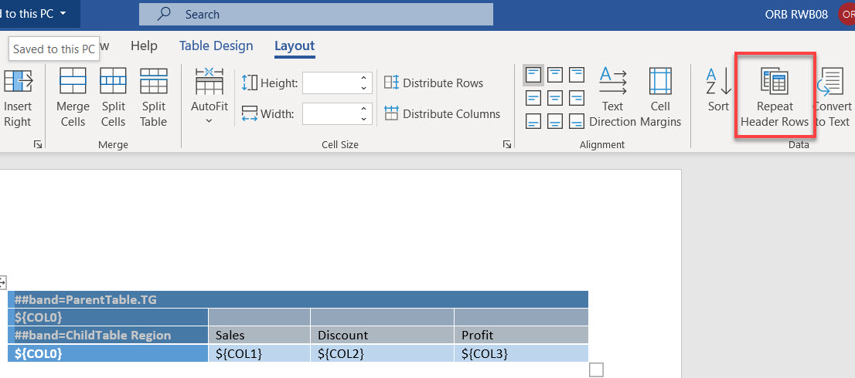

**Output:**

The figure below illustrates the output of the above template, where the header is not repeated in the second page.

Table Grouping is done State-wise, hence, the data from different states (Arizona and California) is displayed below.

 In the figure below, the data for the state California ends in the second page but the Headers are not repeated.

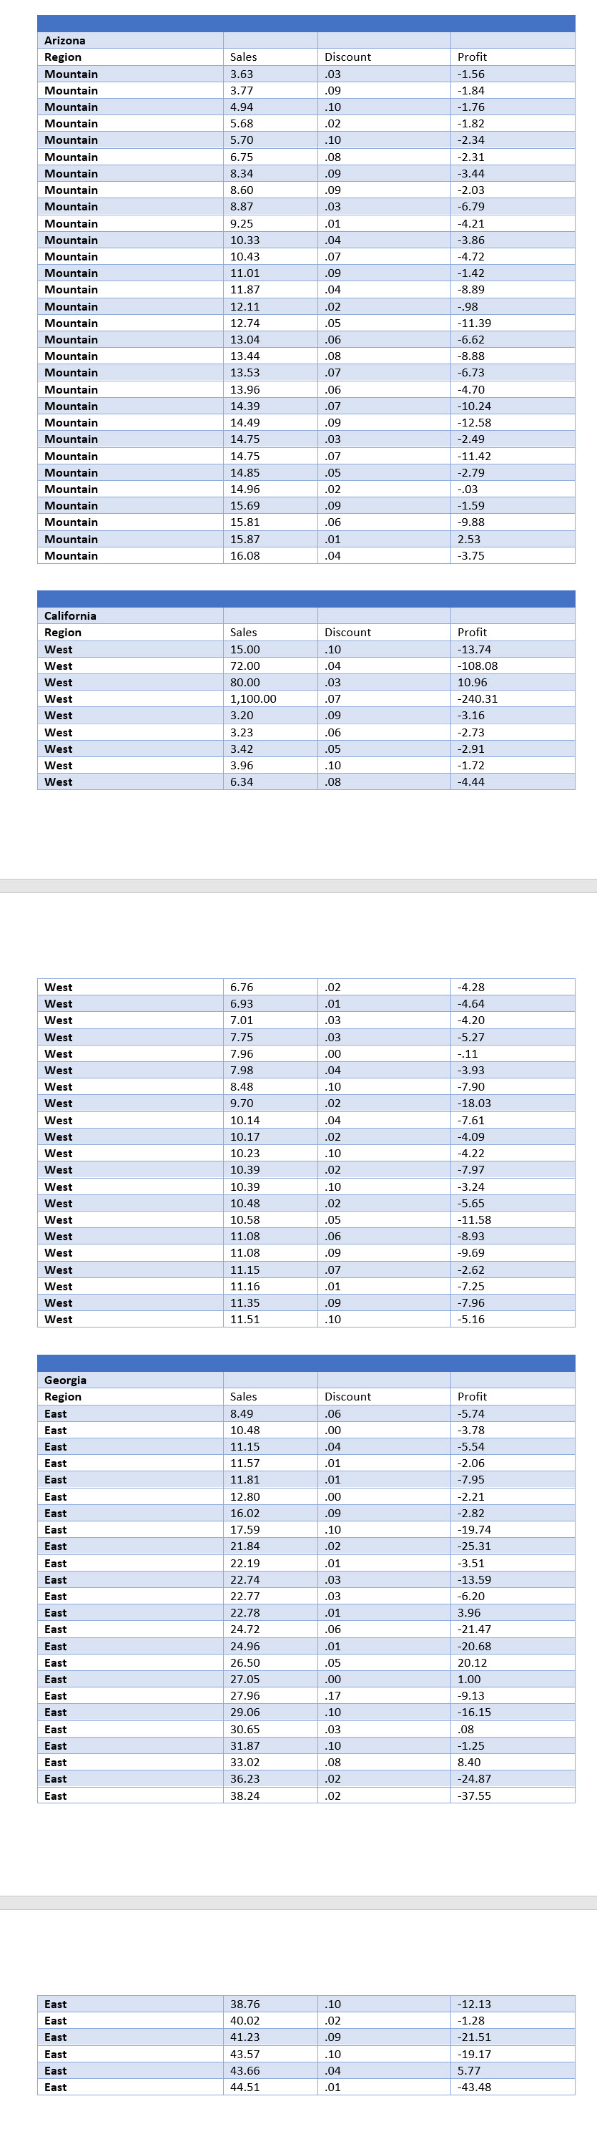

When no Table Grouping or no Page Break is applied, then it’s a normal table and the output is similar to Scenario 2 in the above section.

### Applying Word Template to Publisher Report

1. Create a New Publisher Report.

2. In the **Bands** section, under **MainBand**, create a band “ParentTable”.

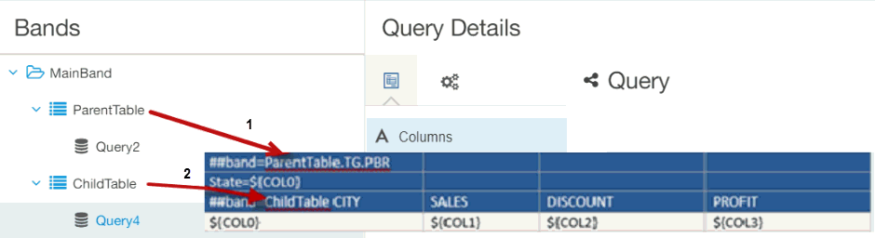

* As shown in the above figure, the band “ParentTable” in publisher report maps to the band “ParentTable” in the Word template (highlighted as “1”).
* Also, the child band “ChildTable” in publisher report maps to the band “ChildTable” in the Word template (highlighted as “2”).

**Note**: One child band cannot have another child band under it.

3. Right-click “ParentTable” band, and then click **New Query** to create a new query “Query 2”.

* When “Query 2” is selected, **Query Details** section appears.

4. Drag and drop the required columns from business object area to the **Columns** section under **Configurator** tab.

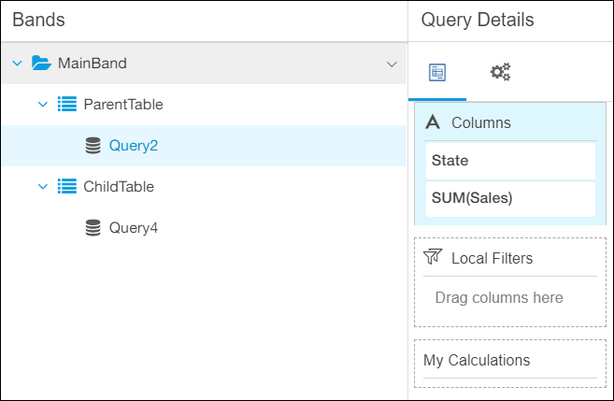

5. Right-click the “ParentTable” band, and then click **New Band** to create a child band “ChildTable”.

6. Right-click the Child Table, and then click **New Query**, “Query 4”.

* Here, the Parent and Child bands are created to enable grouping.
* When “Query 4” is selected, **Query Details** section appears.

7. Drag and drop the required columns from business object area to the **Configurator** tab in the **Query Details** section.

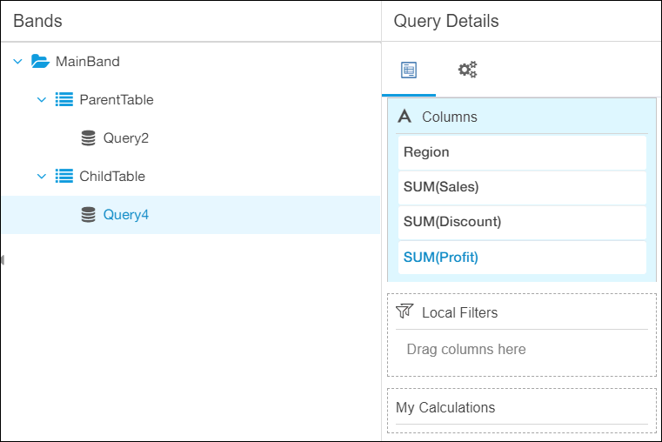

8. In the **Local** **Filters** section, drag the required column and set the filter. Refer **Local Filters.**

* **Example**: Required Column: State
* **Example**: Required Condition: equals
* **Example**: Local Filter: ${ParentTable.COL0}

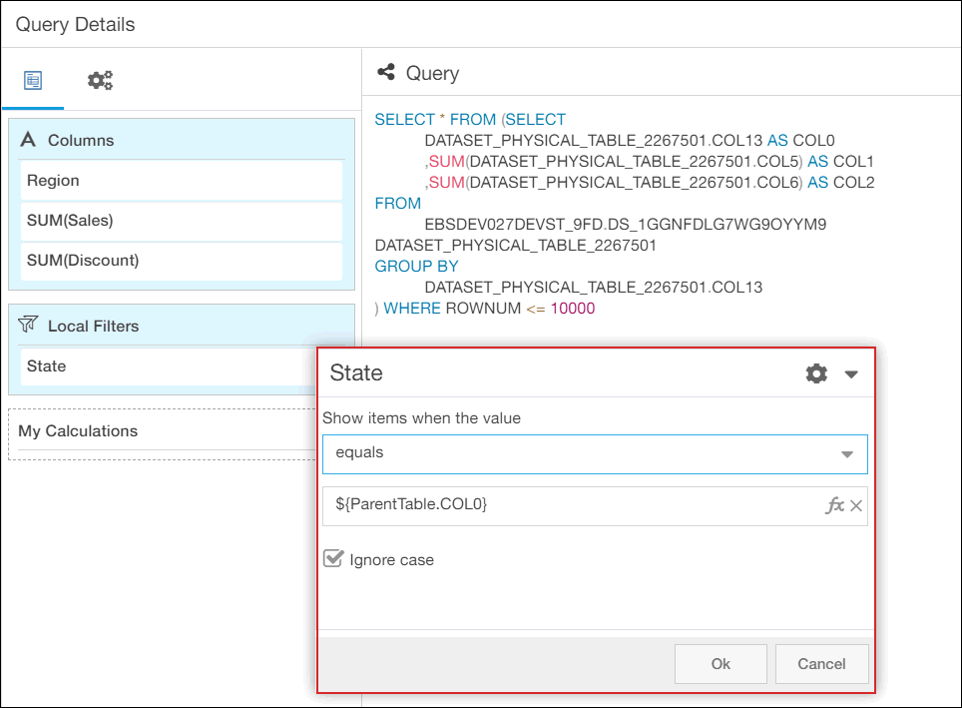

9. To save the changes, click **Save.**

Once the publisher report supporting grouping is created, then upload the word templates mentioned above using **Templates** option. See *Applying Word Template to Publisher Reports*for more information

To view the output, see *Viewing Publisher Report in Word* for more information.

## Viewing the Output

**To view the output**

1. Switch to **View Mode** from **Edit Mode**.

2. In the **View Mode**, from the available templates (highlighted as “1”), select the required template.

3. From the **Select Output** box, select the required output, and then click **Run**.

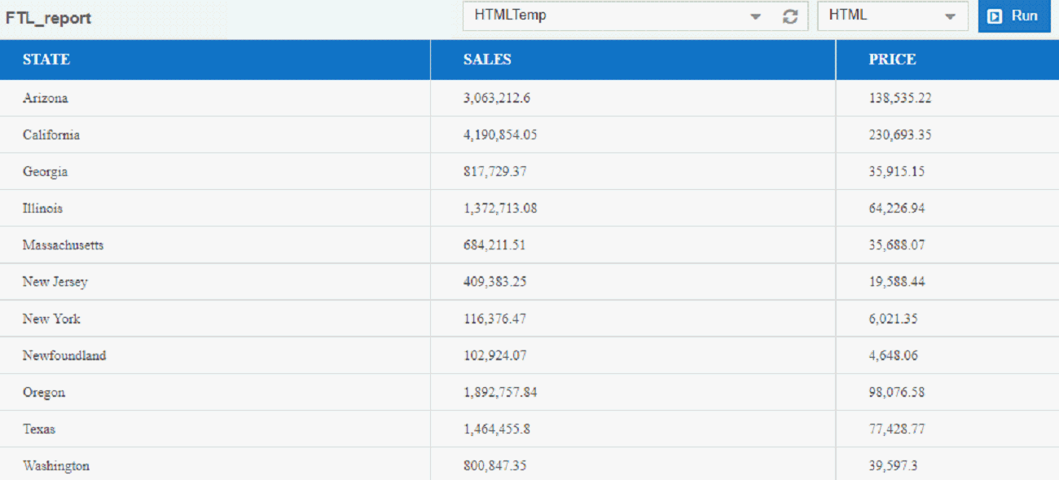

4. The output gets downloaded as HTML and TXT.

5. To view different output scenarios, refer to *Creating a Word Template with Grouping and Page Break*.

6. The process of viewing Excel or HTML outputs is same as this process.

## Options

### Options

Options provides the following:

* Properties
* Templates
* Generate Link
* Delivery Plans

### Properties

**To set the properties of a Publisher Report**

1. On the right-hand side corner, click **Options**, and then click **Properties**.

2. **Properties** dialog appears.

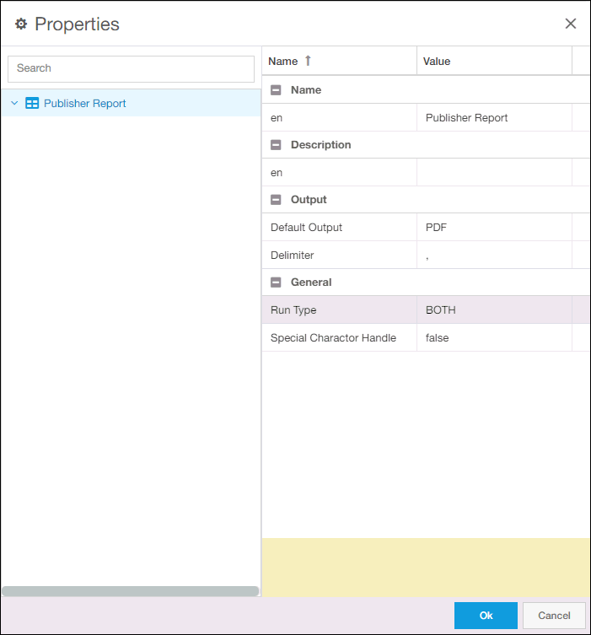

3. In the **Properties** dialog, perform the following:

* In the **Name** box, type the name of the report.
* In the **Description** box, type the description of the report.
* Under **Output** section , the following options appears:
  1. **Default Output** 
     + This option have the following output types
       1. **Image**
       2. **HTML**
       3. **PDF**

**Note**: The selected default output appears in report schedule window.

* 1. **Delimiter**
     + For more information refer Delimiter Text
* Under **General** section, the following options appears:
  1. **Run** **Type**
     1. **Schedule Only -**This options enables only to schedule the report.
     2. **Run & Schedule (BOTH)-**This option enables to run and schedule the report.
  2. **I**n **Special Character Handle** list, click one of the following option:
     + **false**
     + **true**

4. To save the changes, click **Ok.**

### Templates

**To Upload a New Template**

1. On the right-hand side, click  **Options**, and thenclick **Templates** (highlighted as "1").

2. Templates box appears.

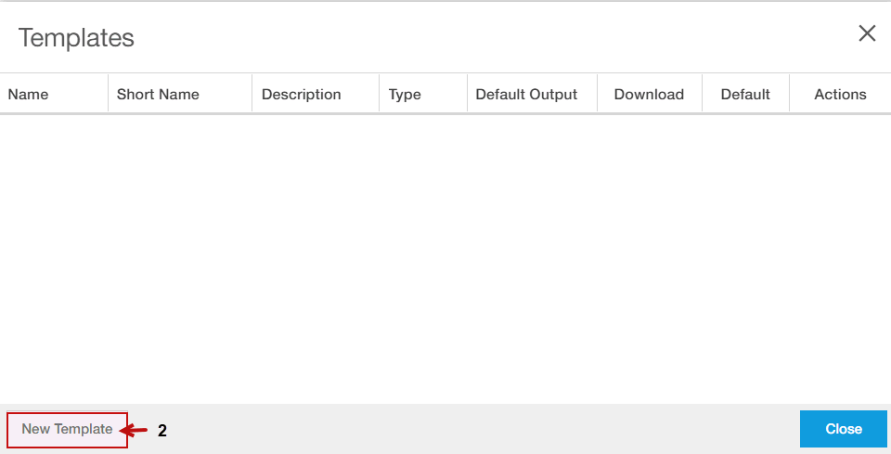

Refer Apply Excel Template to Publish Report

### Generate Link PR

The Generate Link option is similar for all the Reports mentioned below.

* Data Reports
* Analysis
* Dashboards
* Publisher Reports
* Script Reports.

For more information see  Generating Report Link

### Delivery Plans

The Delivery plans for publisher reports is same as Data Reports. See Delivery Plans for more information.

For a **Publisher Report,** the **Report Mapping Fields** are considered from the first band, first query columns.